Participatory housing - Brno, Bohunice
The installation of architectural models, sketches and collages presents new housing concepts for the 21st century. The exhibition is the result of a unique international collaboration between five universities, 42 students, 10 teachers, the Barcelona Self-Office Studio, VIPER Gallery and the LINA Community platform. During a week-long workshop, the students designed new and fresh forms of housing in the Bohunice area of Brno. The exhibition entitled Participatory Housing - Brno, Bohunice will open on Saturday 18 March 2023 at 5pm at the MINI Gallery at the Faculty of Architecture.
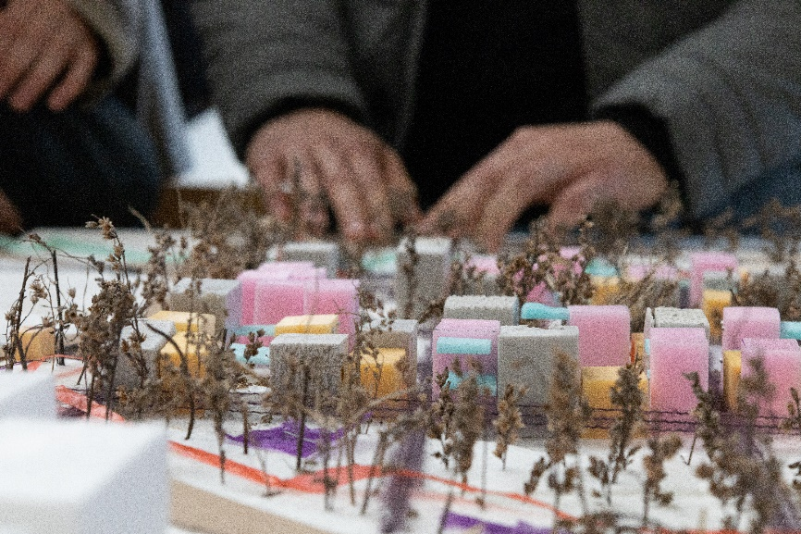
Participatory housing means a wide range and degree of active involvement of residents in the preparation, use and management of housing. The aim of the workshop was to create a residential complex in the spirit of participation. The main theme of collaborative working was reflected not only in the designs themselves, but also in the group work in the design process.
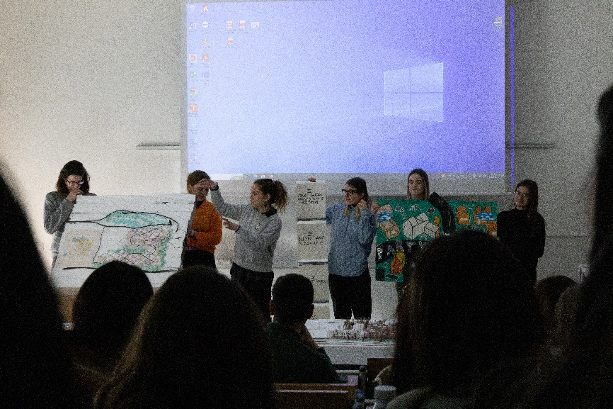
Workshop lecturers:
Laura Solsona and Eduard Fernàndez (self-office); Radek Toman, Kristina Richter Adamson, Radek Suchánek (Faculty of Architecture, Brno University of Technology); Elsa Turkusic, Isra Tatlic (Faculty of Architecture, University of Sarajevo); Igor Kuvac, Nevena Novakovic, Maja Ilic (Faculty for Architecture, Civil Engineering and Geodesy, University of Banja Luka); Anica Draganic, Maria Siladji (Faculty of Technical Sciences, Department of Architecture and Urbanism, University of Novi Sad); Slavica Stamatovic Vuckovic (Faculty of Architecture, University of Montenegro)
Workshop participants:
Anna Divoková, Eva Gebhardtová, Adam Helbich, Daniel Chowaniec, Charlotte Chupáčová, Violetta Iakubova, Kamila Kněbortová, Aneta Koželuhová, Helena Kukuľová, Alžběta Nešporová, Anežka Ondračková, Kateřina Syrovátková, Vojtěch Zajíček, Veronika Zytová (Faculty of Architecture, Brno University of Technology); Belkisa Arapović, Halima Avdić, Hena Begović, Suada Čamdžić, Dalibor Jakić, Armin Karalić, Haris Kozlica, Marija Popović, (University of Sarajevo); Marko Djuric, Jovana Kruščić, Jana Mitrović, Nina Nikolić, Marijana Rovčanin, Aleksandra Vešović, Lejla Višnjić, Ilinka Lalatovic, (University of Montenegro); Jovan Bajic, Nina Čegar, Teodora Jokšić, Isidora Ratajac, Dajana Stegic, (University of Novi Sad); Branka Jakovljević, Andrea Jeremić, Dragoljub Kopranović, Nemanja Popović, Željana Popović, Rastko Sinadinović, (University of Banja Luka)
The exhibition will be on display until 7 April 2023, Poříčí 5, 639 00 Brno
